PROJECT 5 - BORROWDALE MOSS, PEATLAND RESTORATION

Report to June 2014

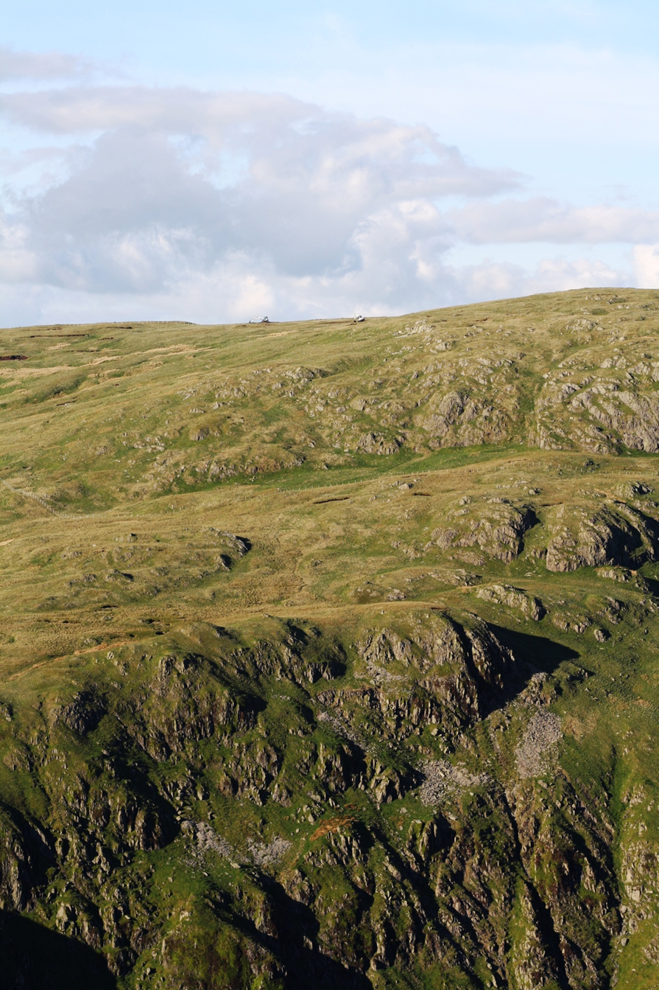

Background
Borrowdale Moss is an extensive area of blanket bog occupying the head of Borrowdale and the heads of the adjacent valleys of Crookdale and Bannisdale, immediately south of the large blanket bogs of the Shap Fells SSSI. Whilst scattered patches of intact blanket bog remain over the majority of the site extensive, linear peat hags have left an undulating surface with extensive species-poor vegetation on eroded sections and exposed dry peat.

The Peatland Restoration project aims to address diffuse pollution issues concerning the River Sprint (tributary of the Kent) and Borrow beck (tributary of the Lune) in particular the issue of degraded peatland in the headwaters. Drain-blocking and re-vegetation of bare peat has been shown to reduce particulate organic carbon (POC) and dissolved organic carbon (DOC) downstream, reduce carbon loss and there is growing evidence of a hydrological response changing to a less ‘flashy’ character. Peatland restoration therefore benefits not only peatland soils, vegetation and hydrological ecosystem services but also stream water quality and biodiversity downstream.

Methods
Borrowdale Moss was walked and ground-surveys undertaken. Data, collected on a mapping computer, were uploaded to a PC for editing to produce GIS tables with information on the size and type of peat erosion features. Similar tables were produced to show peat depth. Additional data collected on paper maps were also inputted to these tables.

Borrowdale Moss was flown in September 2012 to obtain high-resolution aerial photos and digital elevation models (DEM). It took several days to download all the data, convert it into a compatible format and find software able to process the DEM. The resultant maps also identified areas that required ‘ground-truthing’ the following year (this was complete by February 2013).

Figs 1-3 show examples of the digital mapping using the flown aerial photographs.

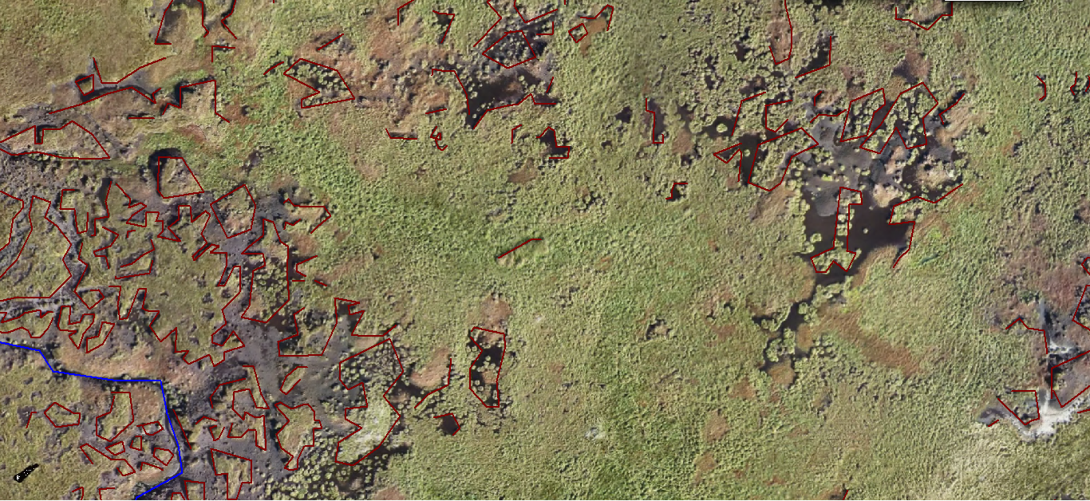
Fig 1: Small section of aerial photographs with digital mapping of erosion features by eye.

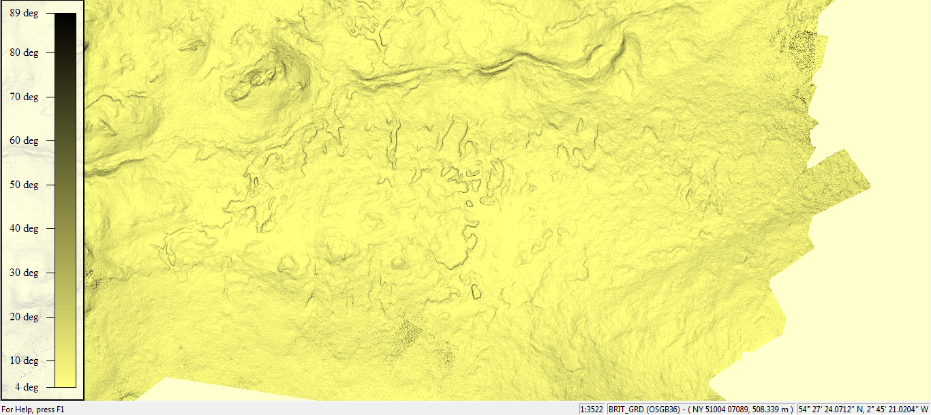
Fig 2: Screenshot of part of Digital Elevation Model, showing steep slopes in grey, including erosion features

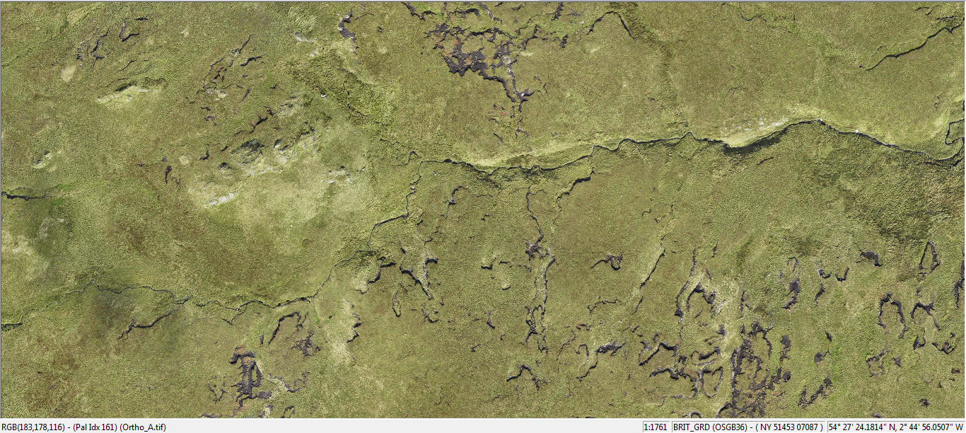
Fig 3: Screenshot of aerial photo of above area, showing peat hags and erosion gullies

The resultant outputs formed the basis for plans for the proposed works, so potential contractors could tender for the capital works.

Capital Works
Barker and Bland Ltd, of Heltondale, Penrith were appointed as contractors and additional work was undertaken in securing a derogation from the Higher Level Stewardship agreement with Natural England, completing all the health and safety requirements as well as liaising at all time with the land owner and farm manager.

Capital works started on the Source to Sea project at Borrowdale Moss in March. Earlier access to the site with diggers had been restricted due to deer culling.

Work included:
- Collection of Sphagnum and other mosses from the site which will be used as a nurse crop to protect bare peat surfaces;
- Collection of heather brash to enable the application of treated heather seed to enable re-vegetation;
- Re-profiling of steep erosion faces to be levelled and re-turfed using vegetation from the site.

Photos 1 and 2 illustrate the typical work undertaken. Photo 1 shows the erosion feature before the diggers has set to work. The vertical hag has bare peat faces. Photo 2 shows after the digger has finished, re-profiling the erosion feature to have a less severe angle of drop and covering the bare peat with vegetation helping encourage re-vegetation and preventing further peat loss.

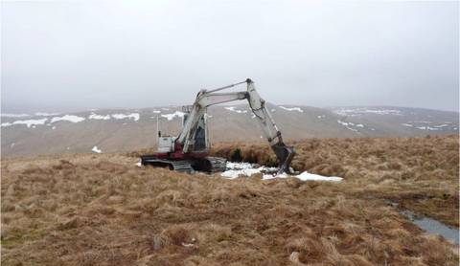
Photo 1: Peat hag before re-profiling

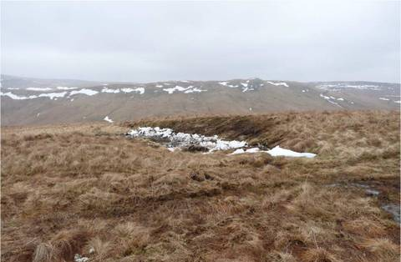
Photo 2: Peat hag after re-profiling

A tractor with cut-and-collect flail cut moorland vegetation from nearby, selected because it contained a high percentage of mosses. These include dry heathland mosses that are suitable as pioneer species, and the Sphagnum mosses needed to allow peat to form actively again. A tracked dumper carried bags of cut material across the sensitive peat habitats to the bare peat.

A bespoke spreader unit mounted on a low-ground pressure Softrak machine spread the chopped cuttings thinly onto the bare peat. The vegetation acts as a mulch to protect the moss to allow it to grow and bind the friable bare peat surface. Moss makes an ideal nurse crop as it will not attract livestock grazing in the same way as young grasses and other herbaceous plants. Heather seed was also spread, and other moorland plants are expected to self-seed from the mulch.

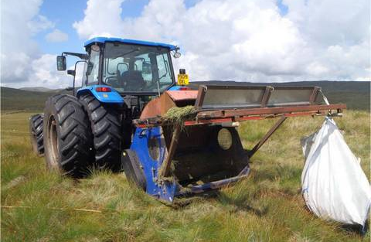
Photo 3: Small tractor-mounted cutter used to collect moss and moorland vegetation
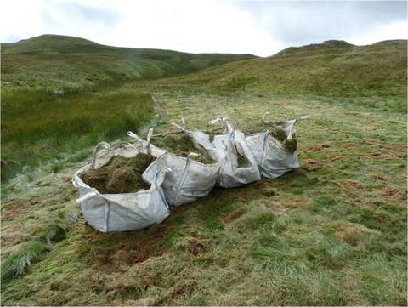
Photo 4: An area recently cut to collect Sphagnum moss

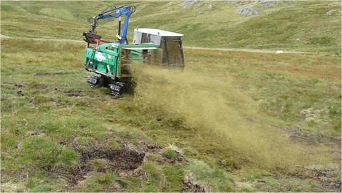
Photo 5: Spreading moss onto bare peat

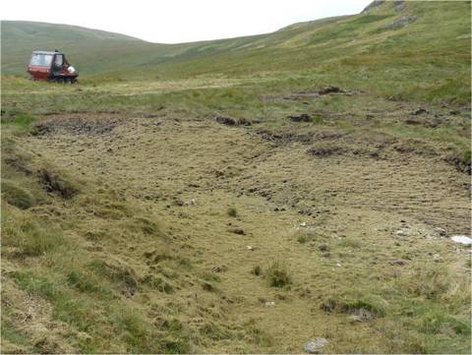
Photo 6: Immediately after spreading of moss and mulch

The harvesting and spreading of Sphagnum moss is reliant on the weather remaining wet, preventing the moss drying out and blowing away. Prolonged periods of dry weather delayed the operations were until later in the summer of 2013 and 2014.

In the worst areas of erosion, volunteers collected Cotton-grass (Eriophorum spp.) plants from pools on the site, for planting out into the areas devoid of vegetation, so their roots can help bind the soil.

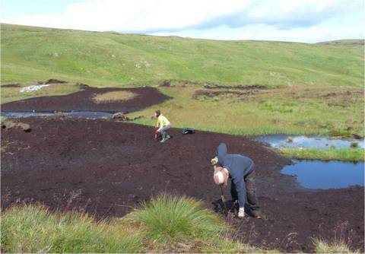
Photo 7: CWT volunteers planting Cotton-grass

Where possible the excavators made small bunds to encourage water pooling within the gully systems.

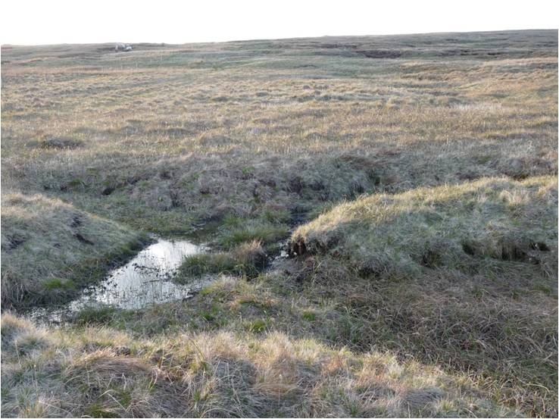
Photo 8: Bunded gullies forming pools

Survey work
As work progressed, the project officer surveyed the work sites to ensure there was no damage to rare plants.

Prior to cutting, surveyors took quadrat data on the areas to be cut, and on bare peat areas to be spread with moss. This will enable future monitoring to demonstrate recovery of the vegetation.

The county bryophyte recorder helped collect accurate data on the extent of Sphagnum moss cover.

A team of volunteers conducted weekly bird surveys to ensure no bird nests were disturbed or damaged during the work.

Outputs
Up to end of June 2014:
- 82.6km total length of eroding peat faces nave been stabilised: gullies 15.8km x2 sides = 31.6km, hags 51km of faces. These are estimates based on mapping from aerial photographs. Note that this may be subject to slight change on completion of the work when final data from our contractor is received.
- 2.2km blocked grips

Monitoring of the 2013 work has shown encouraging signs of success. All the re-turfed areas appear stable, with the vegetation actively growing. Where bunds were made within the erosion gullies, these have remained intact, holding shallow water where bog vegetation is starting to colonise, and sediment is accumulating.

The areas spread with moss species in 2013 were monitored in May 2014 using 6 randomly placed quadrats. This found an average of 58 small moss plants growing per square metre, with an average of nine Sphagnum plants. This compares well to the target of 40 plants per square metre (achieved at a similar reference site in Yorkshire, where complete cover was achieved in 3 years).

One concern Is that approximately 10% of the work had been damaged by sheep trampling. Where many of the peat hags that sheep formerly sheltered under have removed, the sheep are concentrating on the few remaining hags that the machinery could not reached. Fencing the largest area of bare peat to increase the chances of successful restoration is under consideration.

A pair of golden plover successfully nested near to a work area, and surveyors recorded one chick feeding in the restored section. The team also recorded a red kite foraging in the recently disturbed ground.

