Contrasting Landscapes in Lewisham: Ladywell Fields
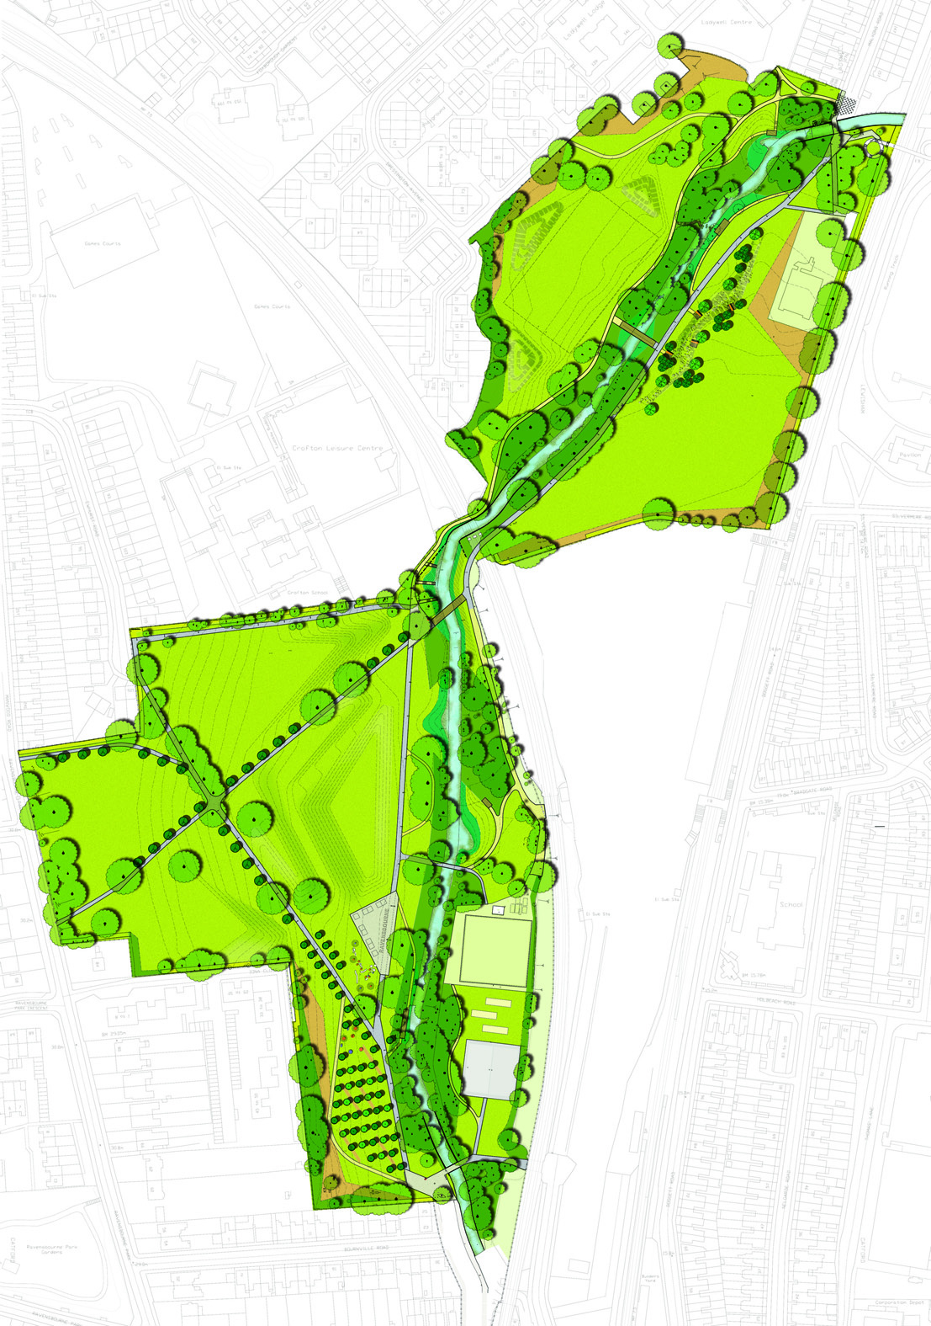
A river restoration project within an existing park. The scheme has created new river channels, backwaters, pools and riffles, and greatly improved habitats within the river corridor along with better access and educational benefits.

This riverside park has been transformed in two phases, the first phase part of EU funding in 2007 and the second phase completed earlier this year. The overriding concept has been to build upon the park’s greatest natural asset – The River Ravensbourne. The project has revived the river by uplifting its parkland setting through re-graded banks and the creation of a new waterscape of backwaters, toes, pools and riffles. Improvements also provide better access to the waterside and enriched habitats and natural biodiversity.
The first phase was centered on the creation of a new course for a stretch of the river allowing it to meander naturally through the fields, animating the parkland. The creation of riverside viewing platforms and inviting park entrances encourage people to use and enjoy the park.
The second phase removed concrete culverts from the river enhancing the water environment, and introduced new social and engaging play spaces. Hand pumped fountains splash water over large boulders in the dry river bed area creating a unique, interactive and educational space. An enhanced footpath network with new lighting, boardwalks and park furniture provides new links to surrounding areas connecting the local community to their parkland.

Native tree planting, wild flowers and self seeding areas have been established both along the river banks throughout the park. While contributing to creating diverse, rich biodiversity habitats the planting embellishes the parkland making it an attractive and enjoyable place to be.
