Key information
Location: New Cumnock, Ayrshire, Scotland | Status: Completed
Start date: June 2011 | Completion date: August 2012
Cost: £400k

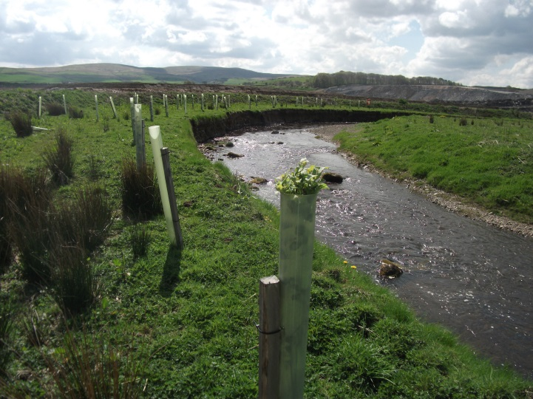
Key features
Enhancing ecological habitats and riparian corridors
The river was sensitively diverted using techniques that allowed natural features to evolve

- River realignment
- Habitat enhancement
- Improved salmon spawning
- Biodiversity/Conservation
- Riparian ecological corridors
- Natural river geomorphological structure
- Improved river resilience
- Socio-economic benefits
- Stakeholder engagement
- Sustainable flood risk management

Project background and objectives
Kier has been mining at the Greenburn Surface Mine Complex since 2003, employing 50% of staff from within a 10-mile radius, in an area of high unemployment.
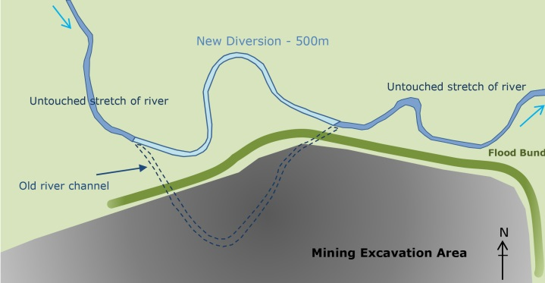
The opportunity to improve the river through diversion
The river realignment delivered a multi-functionality river reach with multiple ecosystem service

An opportunity was realised where the River Nith, which runs through the site, could be enhanced with ecologically healthier reaches. The existing river reach was degraded because of historical agricultural pressures associated with vegetation clearance, excessive cattle poaching and bank reinforcement. Through realigning 500m of the river, the recovery of high quality coal resources in the area continued, which in turn enabled the considerable funding required to realise this project.

The river is home to many thriving salmon fishing beats and the upper reaches of the watercourse are important salmon spawning grounds. The catch of migratory salmonids in the River Nith contributes over £2million to the local economy annually. This project has taken cognisance of this and other important wildlife habitats to offset the potential impacts of the diversion works.
Our objectives for the realignment included:
- Enhance river and riparian habitats to encourage high biodiversity of fauna, including: Eurasian otter, Atlantic salmon, lamprey, wading and passerine birds, bats and amphibians
- Stop cattle poaching
- Improve the fishery potential of the river to leave a lasting legacy
- Accommodate periodic flooding within the riparian habitat to offer flood attenuation

Delivering a reach with improved ecology
Kier spent six years researching and studying the River Nith with technical and scientific specialists, building on knowledge developed in this catchment. The scientific approach and stakeholder engagement was instrumental in the successful delivery of this project.
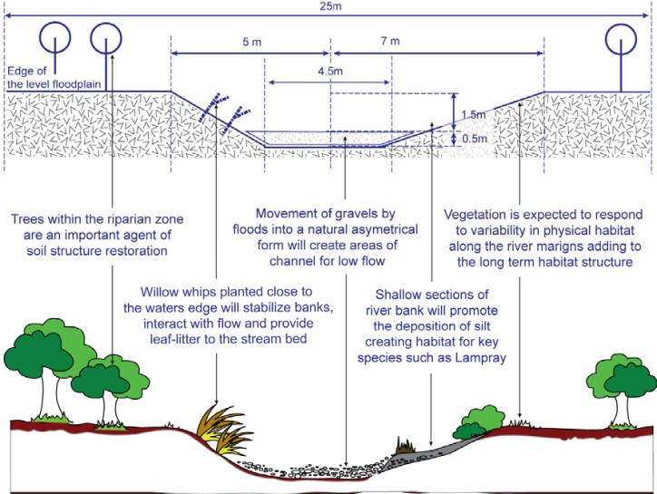
The realignment morphologies are based on a new conceptual approach to design and best practice river engineering methods to create hydraulic conditions which drive the full suite of fluvial processes that would naturally occur in the river.
Matching key geomorphic characteristics
The designed channel dimensions for the realignments derived from data collected on the existing channel and have been developed purely from the requirements of the river ecosystem.
The design considered the range of physical requirements in the channel form necessary to ensure sufficient diversity within which the full suite of hydraulic and geomorphic processes. This produced the most natural channel form as a product of interactions between hydraulic processes and the physical form of the river corridor (i.e. the natural channel type for the given reach conditions).
The key geomorphic characteristics of the existing river local to the reaches were replicated – slope gradient, bank full width and depth, and sinuosity. These variables were measured upstream and downstream with the captured data used to inform and guide the channel design. Replicating the 500m length of the original length and creating a natural slope, maintained the same energy gradient for flow conveyance and sediment transport, which in turn will maintain natural fluvial processes.
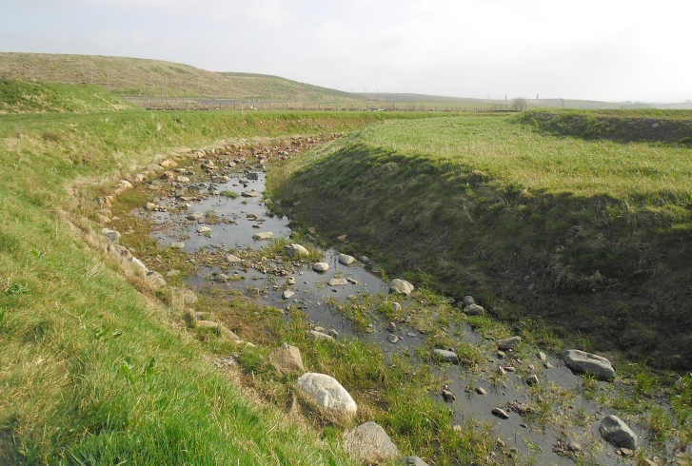
The natural levels of variability, together with sinuosity, aided the development of natural bedforms - allowing pools and riffles to form naturally through self-sorting rather than by creating artificial features.
Allowing the channel to weather and stabilise
The channel was developed a year prior to switching the watercourse, providing time for bankside vegetation to establish.
The diversion improved the ecological status of the river with planting of willow along the diverted channel that naturally stabilise the river banks and once mature will create fish habitat by forming draped foliage at the water’s edge and dropping leaf litter into the water, enhancing the habitat for Atlantic salmon (Salmo salar) and lamprey species (lampetra spp.). In addition, tree planting consisting of hazel, birch, rowan, aspen and hawthorn has been undertaken on the diversion to provide additional natural stability to the banks and riparian corridor habitat that did not previously exist.
Within the river diversion scrapes were formed to promote the retention of water in discrete pools on the flood plain providing habitat for amphibians, birds and invertebrates. In addition, areas of dead wood and rocks were placed on the flood plain to provide amphibian refugia. These are additional features to what was there previously and are beneficial to the ecological status of the river and surrounding habitat.
To deliver the engineering works, our approach was to develop the new channel a year early in June 2011, with water flow introduced in August 2012. This enabled the channel to weather and bankside vegetation to establish reducing the necessity for engineering materials. Fundamentally, the realignment is set within a 50-metre wide river corridor to accommodate natural channel course adjustments. The substrate from old river channel was recovered while still wet ensuring rapid recolonisation of invertebrates and plants in the new channel.
Upon completion of the new reach, electrofishing was used to successfully relocate all fish.

Monitoring outstanding achievements
A 20-year monitoring programme has been implemented in 2014 to review the long-term biological and geomorphological components of the river ecosystem, including invertebrates, fish, riparian vegetation, physical habitat and channel morphology, and flow gauging.
The achievements in restoring the habitat and improving water quality were highlighted by monitoring reports carried out by Centre for River EcoSystem Science (CRESS) at Stirling University, Nith District Salmon Fishery Board (NDSFB) and Environ UK.
Macro-invertebrate Surveys
CRESS conducted surveys of benthic macro invertebrates from upstream, downstream and within realigned sections during October 2012 and October 2014 which highlighted:
- Diversity of macro-invertebrate fauna present (66 species from 48 different families) is consistent with a small tributary in good ecological condition and the taxa identified indicates good water quality
- Sample richness increased from 15 to 33 showing a significant improvement in two years as the river naturalised (120% increase in sample richness)
- The community structure was analysed using Shannon’s index of diversity, statistically showing negligible differences between the realigned habitats and the good quality controls upstream and downstream.
- The median Ecological Quality Indices of all samples was 0.95 - a score at the top end of ‘good ecological status’
NDSFB Electrofishing Survey
The results of the first survey highlighted:
- The channel has performed in a completely predictable manner and fish had utilised this section of river channel as a spawning site.
- Salmon fry increased at each of the six survey locations by an average of 21 individuals since 2012
- Two trout parr found in the realigned section in 2012, with 12 found in 2014 - a promising increase of 10 due to the general low abundance throughout the entire Nith system
- Fish densities of juvenile salmonids compared favourably with other Nith sites surveyed during 2014 (41 in total)
- Salmonid species of fish migrated through the diversion channel and successfully spawned upstream, within and downstream of the diversion channel
- Parr aged salmonids have taken up residency within the diversion channel

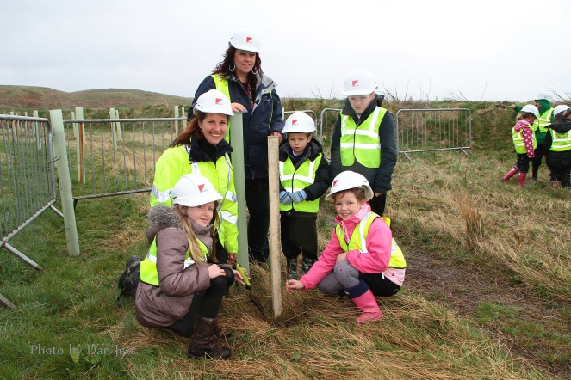
Working together to successfully deliver
Community involvement
Local schoolchildren have the opportunity to participate in enhancing the local environment
Kier delivered the project in partnership with the NDSFB, using their expertise from their wider catchment fishery management and experience from previous realignments upstream, to benefit the realignment.
Halcrow (CH2MHILL) having delivered the design using experience of diverting the River Nith immediately upstream was used to benefit by ensuring lessons learnt were identified and applied.
In addition, we engaged with a wide range of specialists to provide scientific best practice advice, monitoring support and regulatory guidance prior to and during the works. These included Scottish Environment Protection Agency, East Ayrshire Council, Scottish Natural Heritage, anglers clubs, RSPB, Scotland Wildlife Trust and local communities.
The local community has played an important part in the success of the realignment. An area of enhanced restoration on the site was designed in collaboration with New Cumnock Primary School, where they were able to instil their ecological aims within the design. In the long-term, the children will be able to monitor the progress of the realignment and help enhance the wider site.
“…the project involving the children of New Cumnock Primary School is imaginative and forward looking…involves children in active learning through a landscape design project and in positive activities such as tree planting…the company is demonstrating a highly responsible attitude to the environment and landscape…”
Graham Short, Executive Director of Educational and Social Services - East Ayrshire Council

Benefits of the scheme
The realignment project has provided the following environmental, social and economic benefits:
- Enhanced ecological status: Channel design created hydraulic conditions to drive the full suite of fluvial processes that naturally occur in a river to create long term good ecological status.
- Riparian corridors: Trees will establish over the long term providing stability along the banks. The trees will also enhance foraging for bats and other species along newly created riparian corridors.
- Stability: Willow whips along the water’s edge provide additional stability and natural level of erosion resistance while aiding the development of the natural form and suitable environ for salmon spawning.
- Habitat creation: Creation of different habitats will provide important refuge areas for river species
- Socio-economic: Improved spawning beds will maintain and enhance the fishery value - fishing in the River Nith contributes £2.2million to the local economy annually. The mine extension safeguarded 107 jobs for 4½ years and supported 113 further indirect and induced jobs primarily for local workforce: adding significant contribution to the local economy.
- Flood Protection: The energy slope and median dimensions allow means that instream flow conveyance will remain virtually unaltered by the realignments.

Award-winning project
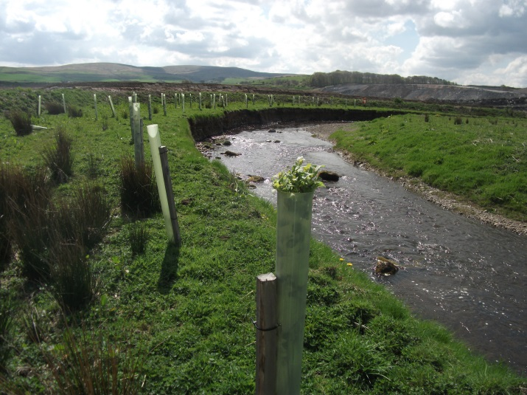
The project has been formally recognised by a number of awards, most notably the Green Apple Awards for Environmental Best Practice 2013 and Excellent rating for Environmental Performance 2012. In addition, the site has been award five consecutive RoSPA Gold Award 2009-2013 and The Coal Authority Award for Environmental Performance 2005
A natural environment
A prosperous aquatic ecosystem is developing; fish, invertebrates and vegetation are rapidly recolonising and are expected to improve as the channel matures. This project is an excellent example of river realignment for the purpose of restoration and socio-economic gain in an area of low prosperity.

