

River Wensum Restoration Strategy

Ryburgh End Restoration Scheme

At a glance

River restoration benefits: Improved planform, channel cross-section, flow variation and sediment processes. Improved connectivity between river and floodplain.

Drivers for restoration: Addressing the physical modifications of the river to meet the requirements of the Water Framework Directive; restoring the River Wensum Special Area of Conservation (SAC) to ‘favourable’ status; and contributing to the Chalk Rivers Biodiversity Action Plan and River Wensum Fisheries Action Plan.

Area restored: 1.32 km of the River Wensum between Great Ryburgh Mill and Sennowe Bridge. National Grid Reference TF 96555 26864 to TF 97322 26198.

Environmental impact assessment: No statutory EIA required. As best practice an Environmental Action Plan was produced.

Project Partners: Natural England and the Water Management Alliance.

Construction period: September - December 2011.

Scheme details

The Ryburgh End restoration scheme (covering Unit 49, Reach 21a of the River Wensum Restoration Strategy) extends to 1.32km of river channel between Great Ryburgh Mill and Sennowe Bridge.

A feasibility study identified that reconnection of 1.1km of former channel in the floodplain would significantly improve the ecology and natural functioning of the Special Area of Conservation (SAC) and Site of Special Scientific Interest (SSSI). Faden’s map of Norfolk, published in 1797, shows the river on its original course, as does Bryant’s map of 1826. By the time the Ordnance Survey map was produced in 1886 the old course had been bypassed by a straight channel. This straight, engineered channel was deep and lacked flow and habitat diversity, and its incised form resulted in minimal connectivity with the floodplain.

A key part of the restoration scheme has been to excavate a new link channel to connect the river to the former channel. A “plug” has been placed in the straightened channel in order to divert flows into the new river course. The height of the plug has been set so that high flows can overtop it and use the existing straight channel as an overflow.

Ryburgh End scheme plan

Aerial view of site pre-restoration

The downstream end of the straight channel has been left open, so providing a significant area of backwater habitat of value to fish and other wildlife. The new link channel has been designed to restore some of the geomorphological function that had been removed during construction of the straight channel.

Although disconnected, the line of the original meandering channel remained, fringed in places by mature alders and other trees. We have carefully re-excavated the old channel, leaving the riverbed gravels intact where we have found then, and supplementing them in other areas to provide shallow gravel glides. The significant quantity of site won gravel has resulted in less imported material being required.

In order to match the normal geomorphological features seen on a meandering channel, the design incorporates deeper pools on many of the bends. These provide a number of benefits including slower water for preferential deposition, so increasing the functionality of the glides by reducing sediment flow across them, as well as helping to control encroachment by marginal vegetation and providing refuges for fish and other wildlife. The scheme also incorporates areas of shallow water at the channel edge and a number of bays and backwaters connected to the main channel.

We have installed woody debris within the old channel to vary the flow and shape of the channel, creating physical habitat for many species of plants, invertebrates and fish.

Native species of tree and shrub have been planted in strategic locations to provide areas of riparian shade. These have been fenced to prevent damage by livestock.

Restoration features (lateral berms and gravel glides) have also been constructed to enhance the section of straightened channel upstream of the connection with the link channel.

Environmental initiatives

The scheme has been designed to minimise the use of synthetic and imported materials. Flow deflectors formed from large woody debris (LWD) have been sourced from fallen trees within adjacent woodland. The gravel required to create the glides and plug has been sourced from a local quarry to minimise the carbon impact associated with transportation. Synthetic materials have been discounted from the design entirely.

No waste material has been taken from the site, thus reducing the potential effects on local traffic and the carbon impact of the scheme.

The works were implemented during September and December 2011 to avoid seasonal environmental constraints and minimise the potential for damage to habitats and species. In particular the works have been planned to avoid the bird breeding season and the cyprinid fish spawning season.

Environmental benefits

Restoration of the former channel has resulted in an increase in habitat and flow diversity which will benefit a number of environmental receptors including:

- Geomorphology – naturalisation of river form and improved floodplain connectivity;
- Fish and aquatic invertebrates;
- Aquatic plants (water crowfoot plant communities);
- Water vole.

The scheme will improve the condition of the SSSI and SAC designated habitat and also improve the local landscape character.

We will be completing a programme of ecological monitoring in order to measure the response of the river. Macrophyte surveys completed less than one year after construction has yielded 31 aquatic and marginal plant species including a number associated with Chalk streams. These include Berula erecta (lesser water-parsnip), Callitriche Spp. (water starwort), Veronica anagallis-aquatoc/cantenata (water speedwell) and Catabrosa aquatic (Whole-grass). This indicates good establishment of target community and the frequent occurrence of starwort throughout the realigned channel is indicative of good flow velocities.

Macro invertebrate sampling conducted at three locations within the realigned channel yielded 28 taxa indicating rapid establishment of a species rich assemblage. A number of the taxa are associated with fast to moderate flows and gravel substrates such as Goerid caddisflies and the mayfly Serratella ignite. Biological indices calculated from the community assemblages indicated that new alignment was only slightly sedimented and characterised by a high proportion of flow sensitive taxa.

Post construction fish surveys have recorded nine species including good numbers of stone loach (Barbatula barbatula), dace (Leuciscus leuciscus) and minnow (Phoxinus plhoxinus). Trout (Salmo truta) were also recorded.

We have recorded notable changes to the macrophyte and macro invertebrate communities of the straight channel which has become a backwater habitat since the flow has been diverted along the old meandering channel. As would be expected a marked reduction in the proportion of macrophytes associated with flowing water conditions has been observed. The macro invertebrate flow and sediment community indices indicated a marked reduction in flow and increase in sediment insensitive taxa in response to the change in habitat type.

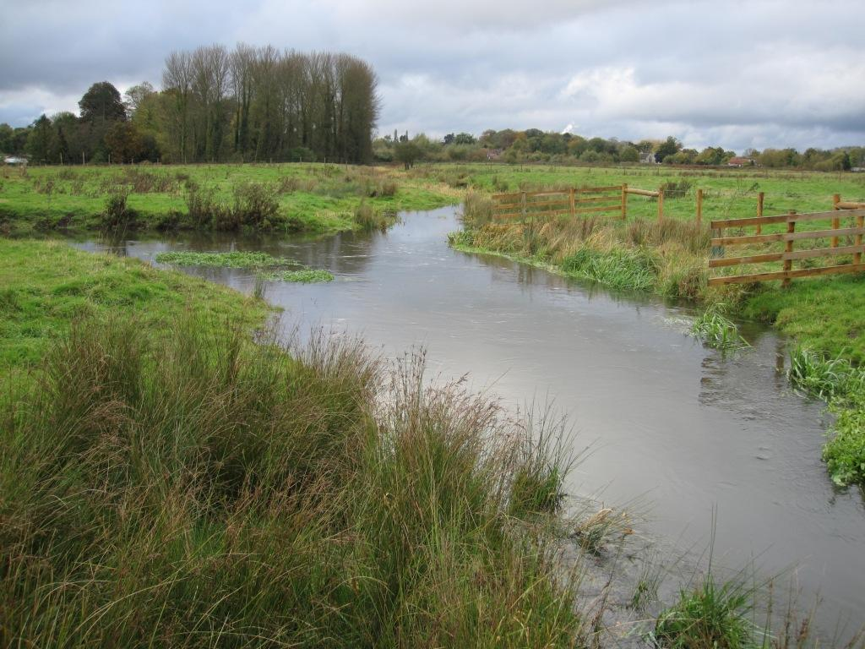
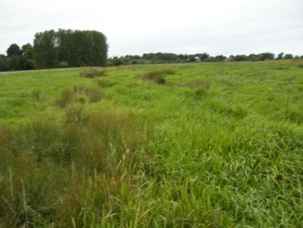

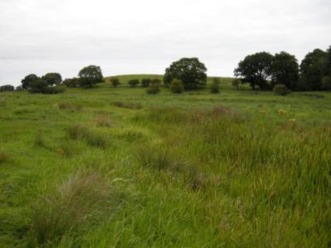
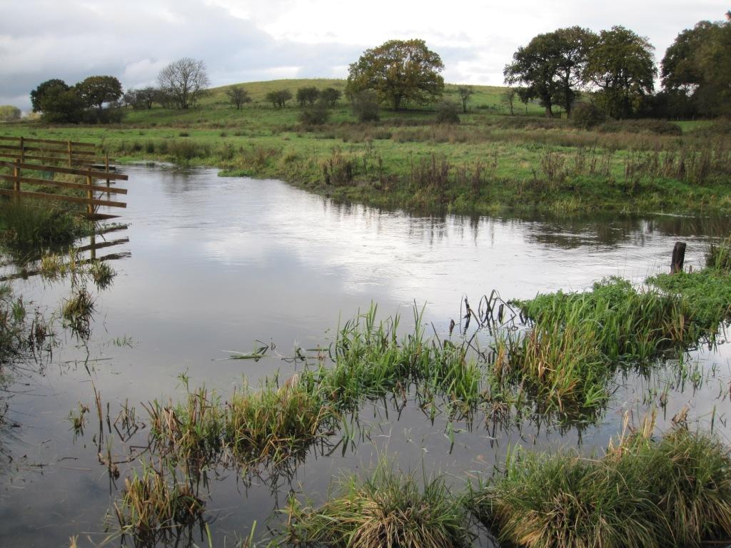

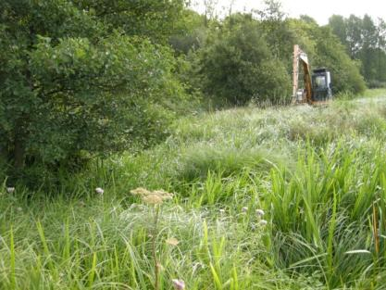
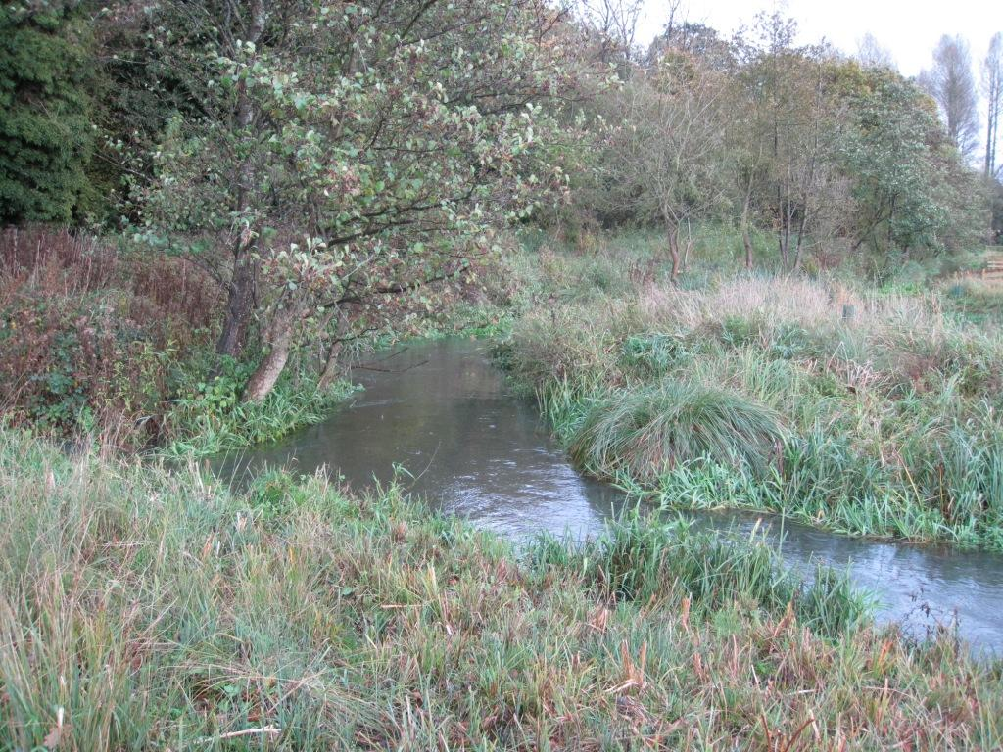

Series of before and after shots taken in September 2011 (left hand side) and November 2012 (right hand side).

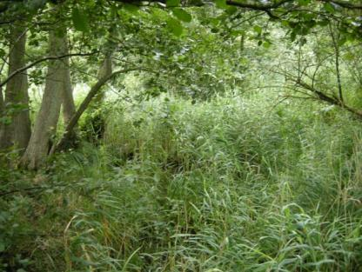
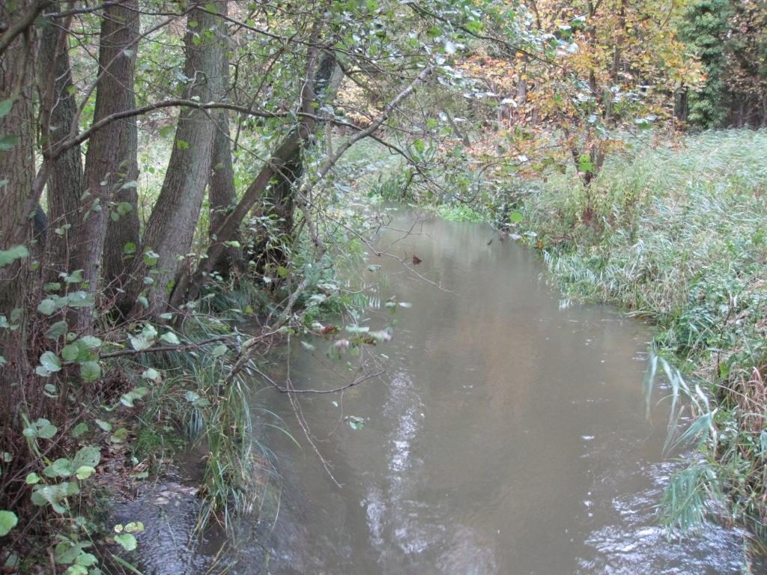

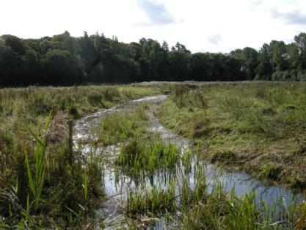
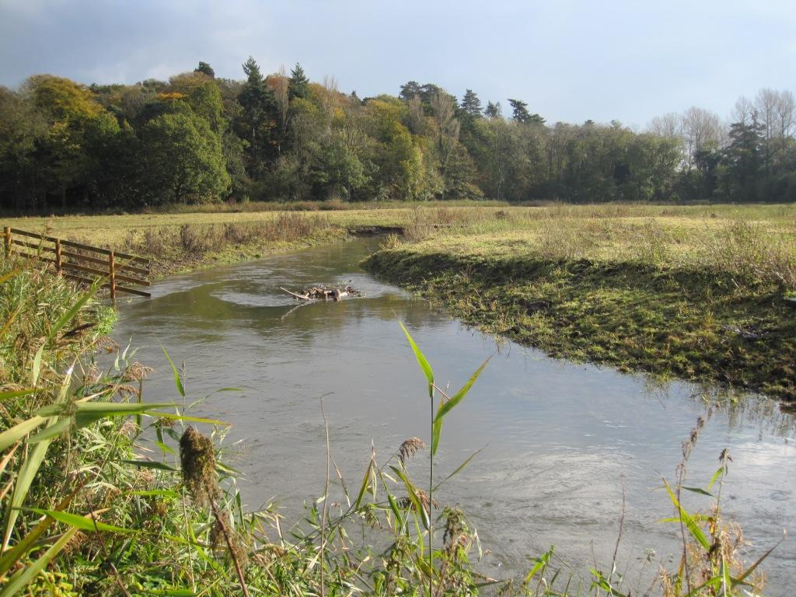

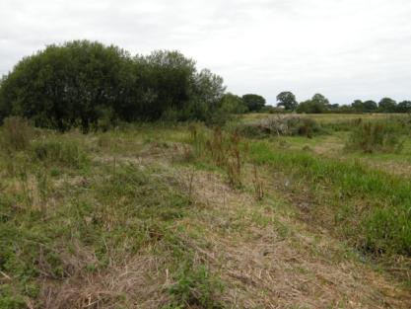
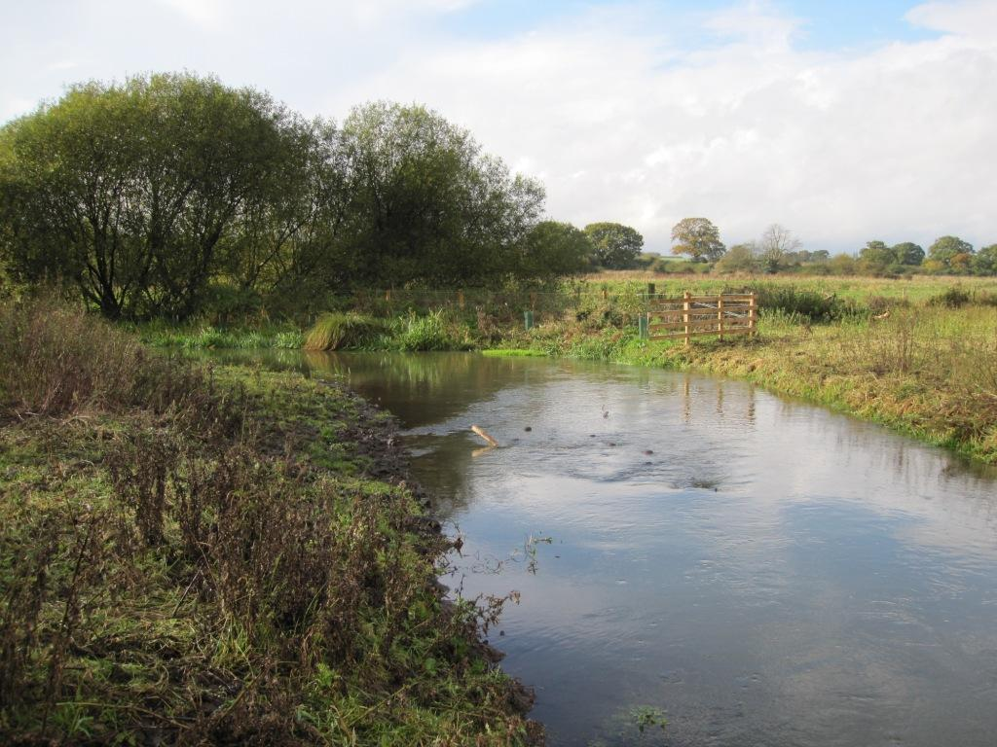

Series of before and after shots taken in September 2011 (left hand side) and November 2012 (right hand side).

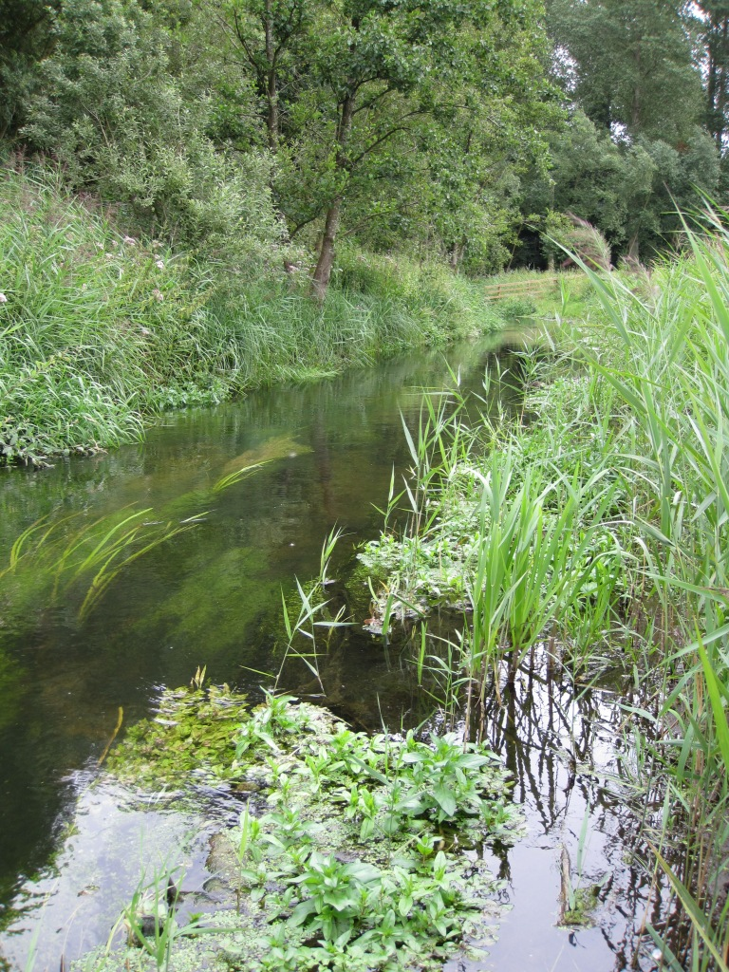

Restored channel with developing submerged aquatic vegetation.

